DEPARTMENT OF MANAGEMENT
Title of the Event | HR Club
Date | 19 January 2026
Time | 3:00 to 3:30 PM
Target Audience | MBA I Semester
No. of Participants | 42
Organization | The Oxford College of Science, Arts, Commerce and Management
Topic Of the Day | “MIND TO MOUTH CHALLENGE”
Type of Activity | Departmental
Venue: | 309
Report prepared by | Dr.M.Surekha
Faculty In-charge | Dr.M.Surekha

Coordinators HOD Vice Principal Principal

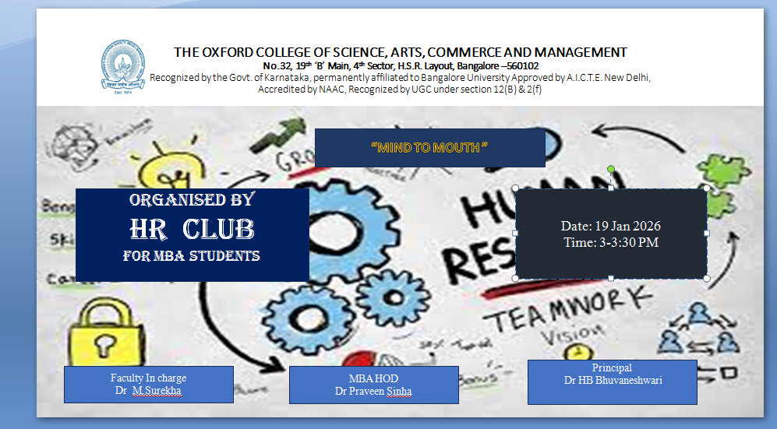
Introduction
The Mind to Mouth Challenge is an interactive communication activity designed to highlight the gap between thinking and speaking. In everyday academic and workplace settings, ideas often lose clarity when they move from the mind to spoken words, leading to misunderstandings and ineffective communication.This activity encourages participants to organize their thoughts, choose the right words, and express ideas clearly under time pressure. It also emphasizes the importance of active listening, as accurate understanding depends not only on how messages are delivered but also on how they are received.Through this challenge, participants experience how clarity, confidence, and simplicity play a crucial role in effective communication. The activity creates a fun yet insightful environment that helps participants recognize common communication barriers and learn practical ways to overcome them.
Description of the Event
Participants are divided into small teams. One participant from each team is given a word, sentence, or concept by the facilitator. The participant must first think and mentally structure the message before explaining it verbally to their team without writing, showing, or using gestures.
The speaker is given a limited amount of time to communicate the idea clearly. Team members listen carefully and try to understand and repeat the message exactly as intended. Any confusion, misinterpretation, or loss of meaning is noted.
After each round, teams discuss what caused misunderstandings—such as unclear wording, overthinking, nervousness, or poor listening. Roles are then rotated so every participant experiences both speaking and listening responsibilities.
The activity continues for multiple rounds with increasing complexity of messages, helping participants practice clarity of thought, effective verbal expression, and active listening under pressure

Outcomes of the Activity
- Participants develop clarity of thought before speaking.
- Improved verbal communication skills and structured expression of ideas.
- Enhanced active listening and attention to details.
- Better understanding of how miscommunication occurs in real-life situations.
- Increased confidence while speaking under time pressure.
- Improved ability to simplify complex ideas for better understanding.
- Strengthened team coordination and collaboration.
- Awareness of the importance of choosing the right words to convey the intended message.

Conclusion
The Mind to Mouth Challenge effectively demonstrates the importance of transforming thoughts into clear and meaningful communication. The activity highlights how even simple ideas can be misunderstood when thoughts are not well-structured or when listening is ineffective. Through active participation, learners gain practical insight into communication barriers and the need for clarity, confidence, and attentiveness in verbal interactions. Overall, the activity reinforces that effective communication is a shared responsibility between the speaker and the listener, making it a valuable learning experience for academic and professional settings.
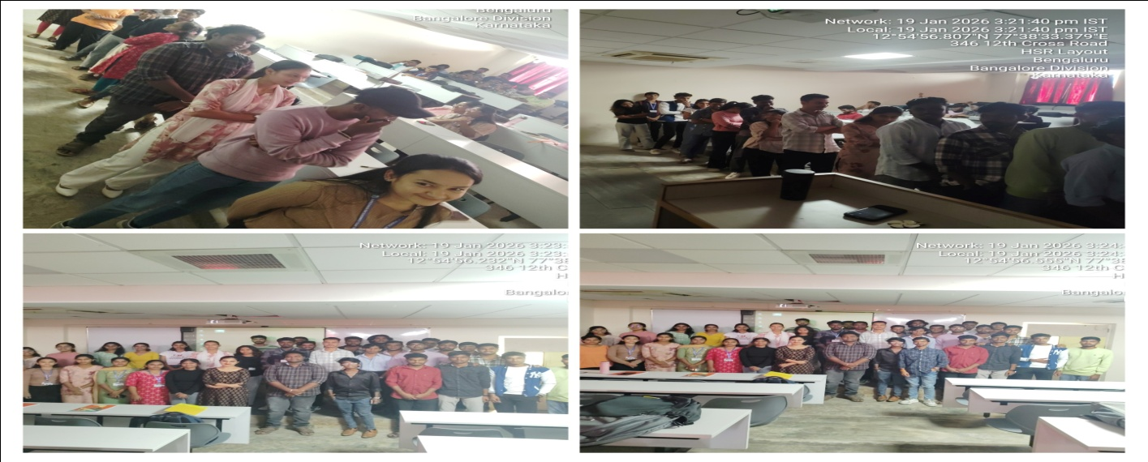

Coordinators HOD Vice Principal Principal

